4. Return the first name, last name and city of all customers who live in Canada. Order the re-

sults first by the last then by the first name.

SQL used:

select first_name,last_name,city from customer,city where country_id in (select country_id from country where country='Canada') order by last_name, first_name;

Output:

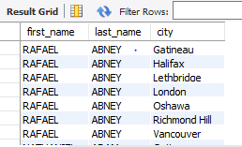

5. How many customers are from Brazil??

SQL used:

select count(customer_id) from customer,country where country='Brazil';



6. Return the "popular countries"? (that is, the ones with more than 20 customer). For each

such country, return its name and its correspond number of customers. Order the result by the

number of customers (descending).

SQL used:

select country, count(country) from customer_list group by country having count(country) > 20 order by count(country) desc;

